Hi David,

The stock key is the system’s inner link for inventory calculation, eg:

The dining chair 25000.03BLK, there is another item# 52600.00BLK as the HMNUM rule changed, this 2 item# are same product and same color, so we use the same “stock key” to statistic inventory qty in case warehouse has both item# ‘s inventory.

cid:image001.png@01CE724D.BE9FE040

The same reason as one product in KD or not KD version (KD means assembly), which will be use different HMNUM.

Attach is the HMNUM create rules Tony final confirmed for you reference, in past, we don't create new HMNUM but just use .01, .02,.03…when same style changed like add tuft on surface or change to KD version…

This key is only used for inner system not sales and my team maintains this key once new inventories coming (New HMNUM on order)

Per my yesterday’s email, for CMS system’s user, they are only 2 Numbers (SKU Order, HMNUM=InventoryNUM) they may use. HMNUM is our inner system’s product item#, SKU Order is the product code we submit to each website. Let me show more examples about these 2 number’s relationships(Stock Key is inner system used):

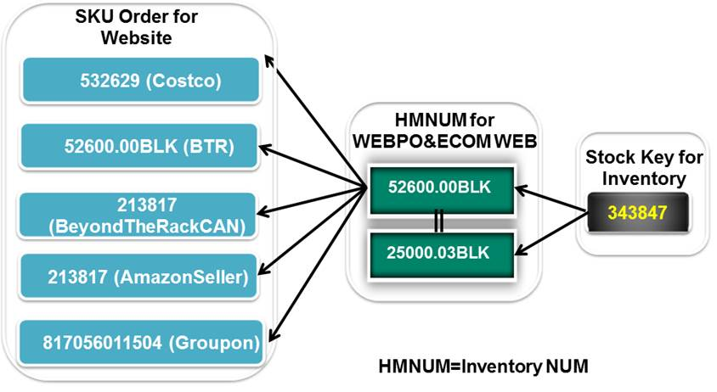

Let me answer your question below:

(1) Is this product/SKU available for order fulfillment?

--LFR: Yes, stock is just system’s inner link, CMS user don’t use it but need to know we use this key to link specific product’s inventory. For outer user, the SKUOrder and HMNUM is enough and CMS system will only use these 2 numbers for order fulfillment.

(2) what are its components?

--LFR:

   a. SKU Order: Base on KAT/ Melissa submits to ECOM WEBSITE, we don’t create it.

   b. HMNUM: We create new HMNUM with 5 prefix by ascending like if the last HMNUM is 54000, we will create 54001 for overall new products, and with “.00” after this 5 prefix, so new HMNUM is 54001.00

                            Sometimes you can see the HMNUM with letter on the postfix like 54001.00RBLBRN, which means material is “Reconstituted Bycast leather”  and color is “BROWN”, we add abbreviated letter for

                            aterial and color as the postfix or HMNUM.

   c. Stock Key: It’s 6 numbers and created by ascending, all are manual created according the HMNUM’s description.

(3) if not currently in stock, when will it be?

--LFR:  If not stock, CMS operation still can search the HMNUM or SKU Order under product search as all products are stored at product table, but the inventory will shows 0.

Hope this makes your more understanding our item# and the system’s logic.

Any problems please let me know.

Brgds!

Larfier

**From:** David Eike [mailto:david@davideike.com]   
**Sent:** 2013年6月26日 3:31  
**To:** Larfier  
**Cc:** 'Jin Jin'; mil@hkpermaisuri.com; 'John Halloran'; olv@hkpermaisuri.com  
**Subject:** Re: Noble House CMS Functional Specification [draft]

Hi Larfier,

Thanks for the detailed breakdown of your stocking system. How is the "stock key" generated (what calculus is used)? Can this be used as a "digest" of a SKU's availability for sale?

At a very high level, we need to find a way to condense these number relationships into a simple data set that tells the CMS operator (1) Is this product/SKU available for order fulfillment?  (2) what are its components?, and (3) if not currently in stock, when will it be?

-David

On Jun 25, 2013, at 2:17 AM, Larfier wrote:

Hi David,

It’s not too difficult for data synchronization from WEBPO/ESS to CMS system, as we already has basic product property on WEBPO( item#, color ,material, dimension, weight..) and product extent property on ECOM WEB ( sell set, selling price, merchant, ship via…), so we can merge both system’s data as a full product for CMS system.

According your below email, we now just develop below 5 items for phase 1, all about products:

1. Product search---OK, but without product configuration part, after finished Phase 1, we will start this part

2. Reporting---OK, but only product and inventory part, no orders, no channels.

3. Lifecycle Management—The product status “unknown->New->Media Creation->Marketing Developing->Complete” is OK

                                          But as all outbound integration components (API or export) are moved to Phase 2, extra status “Active and Discontinued” can’t be achieve for phase 1.

4. Dashboard---Only product without orders, after finished Phase 1, we will start orders report

5. Media Library---OK, only lifestyle and videos interface for Phase 1.

PS:

There is a special key we named “Stock Key” for inventory calculation you may not know. This is the internal product key to calculate same product’s inventory in different HM#.

Let me explain more about this for you. Eg:

1. Right now there 10 item# for specific products, see attach1.

2. Each item’s description, see attach 2

2. The relationship for different item#, see attach 3

Means:

   1 HM# should be in different HM# (as our system’s rule changed and changed), we use “Stock Key” to statistic different HM#’s inventory as one inventory

   1 HM# should be in different SKU Order as we sell in different website

   1 HM# should be in different CartonTag as CartonTag base on batch# and HM#.

Our ECOM WEB system already adds this key when we design; think this should be in CMS system as for system inner used, which system statistic the inventory may some different with when you search by HM# or by SKU Order.

All above confirmed, we will start developing system ASAP.

Brgds!

Larfier

**From:** David Eike [mailto:david@davideike.com]   
**Sent:** 2013年6月25日 8:23  
**To:** Larfier  
**Cc:** 'Jin Jin'; [mil@hkpermaisuri.com](mailto:mil@hkpermaisuri.com); 'John Halloran'  
**Subject:** Re: Noble House CMS Functional Specification [draft]

Hi Larfier,

I've attached an updated version of the CMS specification. To answer your question below, all outbound integration components (API or file export) have been moved to Phase II, which will be scheduled at a later date. After talking to John, it was decided that the basic functionality of product search, reporting, and lifecycle management will be of enough of a benefit to the team to make Phase I (without integration) worthwhile.

For internal data synchronization mechanism between CMS and ESS or WebPO, I will need your feedback to estimate how difficult this will be. The essential goals here are to introduce new products and parts into the CMS system without requiring manual entry (double work), and also to backwards sync SKU/product-specific marketing data back to other systems whenever they are updated in CMS. Perhaps this can be done manually with scheduled bulk data imports.  Anyway, it would be unfortunate if we end up with two systems that did not "agree" with each other about the correct product information.

Note: After reviewing it further, I did not add any reports are alerts for "open orders" that you suggested, since we are trying to focus purely on marketing, lifecycle development and sales analytics.

Thanks!

David

<1.JPG><2.jpg><3.jpg>